Test Project Module 1 / 競賽試題1
(Corporate Design) / （企業識別設計）
WSC2013_TP40_MO1_actual_EN

Submitted by:
Thierry Herman BE
Susanne Moustgaard DN
Terkko Malm FI
Sathish Narayanan IN
Amy Soon SG
Wolfgang Toechterle IT

Contents / 內容
This Test Project proposal consists of the following documentation/files:
- Text Doc: WSC2013_TP40_MOD1_actual_EN
- WSC2013_TP40_MOD1_Folder containing:
  - image files: images
  - Font folder: Kristall Now Pro
  - Given text in file: TEXT_Module_Corporate_Design.rtf
  - QR Code in file: druckkunst.png
  - Bag DieCut in file: BAG_dieCUT.ai
  - Colour profile file: ISOcoated_v2_300_eci.icc, ISOcoated_v2_300_eci.icc

這個試題包含以下文件/檔案：
1. 文字檔案: WSC2013_TP40_MOD1_actual_EN
2. WSC2013_TP40_MOD1_資料夾包含：
- 圖片檔案：images
- 字體檔案：Kristall Now Pro
- 提供的文字檔案：TEXT_Module_Corporate_Design.rtf
- 提供的QR Code檔案：druckkunst.png
- 提供的紙袋刀模檔案：BAG_dieCUT.ai
- 色彩描述檔檔案：ISOcoated_v2_300_eci.icc, ISOcoated_v2_300_eci.icc

Introduction / 說明
From the lead typeface to the Apple Mac:
550 years of printing history at the Museum of Printing Arts Leipzig

從鉛字到蘋果電腦：
在萊比錫印刷藝術博物館裡的550年印刷歷史

The history of the “black art” is one of brilliant inventions, innovations rejected or developed and sudden radical change on a breathtaking scale. And yet it always remains a story about people. At the Leipzig Museum of Printing Arts, the human touch makes printing history come alive again: rare historical machines and printing presses are shown in action, enabling visitors to experience the art of printing with all their senses.

「黑暗藝術」的歷史是最精采的發明之一，在當時拒絕革新或發展和有一些令人讚嘆的規定也會被突然的錯誤改變。直到現在已成為人類的一段故事。在萊比錫印刷藝術博物館，人類的再次接觸使印刷的歷史重新被喚起：稀有的古老器材和印刷機器實際被展示，並且讓參觀者直接實際操作印刷的藝術。

The museum’s collection of around 100 working machines and press for historical casting, composing and printing techniques really brings the history of printing alive combining a museum and an active workshop, visitors still can experience printing process first hand. The Museum of Printing Arts also houses a handcraft book bindery, a workshop of a wood engraving and a unique collection of more than 4,000 different typefaces from European and oriental provenance. The Museum of Printing Arts is based in the former industrial quarter Plagwitz in a listed industrial building that has been in continuous use as a printing house since the early 20th century.

博物館的收藏，大約有100台運作的機器和印刷機用來鑄造字體，排版與印刷技術重新喚起印刷的歷史，透過實作的工作坊和博物館，參觀者可以親身體驗印刷的過程。印刷藝術博物館也設立了手工書裝訂廠、木刻工作坊以及的收藏來自歐洲與東方超過4,000種不同的非常獨特的字體。從20世紀初，印刷藝術博物館將之前Plagwitz印刷工廠的四分之一，繼續沿用作為印刷廠使用。

Three special exhibitions per year focus on individual theme related to printing and all its various facets. The current exhibition, which runs until mid-May 2012 is entitled “From lithography to offset printing, the Kunstanstalt Carl Garte Leipzig and the collection of Hans Garte”. It shows extraordinary examples of multi-colour lithography and early examples of offset printing from the beginning of the twentieth century.

每年三個特展，都專注於與印刷有關的不同主題以及印刷的不同面向。目前的展覽「從石版印刷到平版印刷，萊比錫Kunstanstalt Carl Garte和Hans Garte的收藏」，將展出至2012五月中。這個展覽將展示非常多20世紀早期的多色石版印刷以及早期的平版印刷範例。

The Museum sees the future as lying in intelligent networking of print and Internet along the lines of “Augmented Reality” – with the difference that all the senses are addressed simultaneously at the Museum. When it comes to the media mix of the future, the Museum recommends occasionally taking a look back at the history of printing technology so as to understand the here and now better and actively use expertise from the past as a source of inspiration for the future.

博物館看見未來將處於智慧網絡的印刷以及網路聯繫的「擴增實境」－不同的場景同時呈現在博物館中。當提到未來媒體的交流，博物館建議時常看看過去印刷技術的歷史，以更加了解現今的印刷技術，以及將以前實際使用的技術作為一個資源來激發未來的技術。

Description of project and tasks / 試題與任務說明
The Museum of Printing Arts needs to build an identity that will be used consistently through all its documents. Your job is to create this corporate identity; with colours, photos and illustrations, typefaces, etc. This will be applied to several promotional items including a Letterhead and Business Card, Entry Ticket and Shopping Bag.

印刷藝術博物館需要設計一個企業識別，其識別將會統一使用於所有的文件上。你的工作是設計一個企業識別標誌；可以有色彩、圖片和插畫、字體等等。這將會應用於一些宣傳品，包含信頭、名片、入場券和購物袋。

Throughout the whole project you should consider that the museum represents the art of letterpress printing. Due to this, some documents will be produced with this printing method. When you design remember some of the limitations of letterpress printing. Such as fine lines, large solids and halftone screens or the transparent quality of letterpress Ink.

針對整個試題，你必須考慮這個博物館是以活字版印刷藝術聞名。基於這個原因，有一些文件將會以活字版印刷方式印製。當你設計時請記得活字版印刷的一些限制，如細線、大範圍色彩和半透明或透明的活字版印刷油墨。

Therefore the client asked for a clean and straight forward approach. The Design must be forward-looking and modern. Must explicitly be "not conservative."

因此，客戶要求要一個乾淨與直接明瞭的呈現方式。這個設計必須與有未來性與現代感。一定要明確「不保守」。

Target audience / 目標客群
Individuals and families who are interested in history of the “black art” and related brilliant inventions.

對「黑暗藝術」歷史與相關的精采發明有興趣的個人和家庭。

Task 1: logo / 任務一：標誌設計

The Museum of the Printing Arts needs you to create a logo for the Museum. The logo needs to embody the ideas of printing and all its various facets. From a historical, technical, handcraft view, up to the beginning of the twentieth century.
- The logo should have a compact shape.
- It should be possible to use it for both offset and letterpress printing.
- The logo must include the complete name “Museum of Printing Arts Leipzig”.
- You must prepare the German version, too. “Museum für Druckkunst Leipzig”.
This version of the logo is the same design. This logo will be used in all the German language documents.
- The city name "Leipzig" is an important part of the Logo because of the existence of other similar museums in other cities.

印刷藝術博物館需要你為博物館設計一個標誌。這個標誌必須包含印刷的概念與多元的面向，從歷史的、技術的、手工藝的角度，追溯至20世紀初期。
‧這個標誌的造型必須穩重精緻。
‧這個標誌必須同時供平版印刷與活字版印刷。
‧這個標誌必須包含完整的博物館名稱「Museum of Printing Arts Leipzig」。
‧你也必須製作一個德語版本的博物館名稱「Museum für Druckkunst Leipzig」。這個標誌的設計是與英文版的設計相同的。這個德語版本的標誌將被應用於所有的德語文件上。
‧設計標誌時，這個城市的名稱「Leipzig（萊比錫）」非常重要，因為其他城市有同性質的博物館。

Technical specifications: / 技術規格：
Colours: Two versions of the same logo: a) 2 PMS colour b) CMYK
Include the name of the Pantone number with a colour swatch.
Text for two separate logos with the same design:
English Logo: Museum of Printing Arts Leipzig
German Logo: Museum für Druckkunst Leipzig
Printing: Letterpress and offset printing
Trapping: 0.5 points
Images: Only vectorized images are allowed for the logo

‧色彩：一個標誌兩種色彩版本：a) 2個PMS colour
b) CMYK
包含Pantone色和CMYK的色彩編號，並以色塊標示。
‧兩個版本的博物館文字須用相同的設計：
英語標誌：Museum of Printing Arts Leipzig
德語標誌：Museum für Druckkunst Leipzig
‧印刷：活字版印刷和平版印刷
‧補漏白：0.5 points
‧圖片：標誌設計只能用向量圖製作

You must deliver:
- 1 final folder of your working files for archiving
- 1 Illustrator (ai) file showing the English and the German logo in 2 PMS colours (Pantone Uncoated), as well as the English and the German logo in CMYK on the same Artboard (All 4 on same page)
- 1 PDF/X-3:2002 file of your logo in CMYK (NO SPOT COLOUR INCLUDED)
- 1 A4 printout, mounted on presentation board showing the two versions of the Logo (English and German) as well as the two colour Versions (PMS and CMYK). Display the used colour swatches in a colour chart.

你必須繳交：
‧一個你工作檔案的最終資料夾
‧一個Illustrator (ai)檔案，同時顯示兩種色彩版本的英語和德語標誌：一組為2色Pantone Uncoated色彩、一組為CMYK（四個在同一頁上）
‧一個PDF/X-3:2002的檔案，你的標誌設計色彩為CMYK（不可包含特別色）
‧一個A4輸出，裱貼於展板上，展示兩個版本的標誌（英語和德語版本）以及兩種色彩版本（PMS和CMYK）所用的色彩，以色塊表示。

Task 2: Letterhead and Business Card
任務二：信頭與名片設計

Required elements for both – letterhead and business card:
信頭與名片設計－需包含的元素：

Given text:
Stiftung Werkstattmuseum für Druckkunst
Nonnenstraße 38
D-04229 Leipzig
Tel. +49 341 / 231 62-0
Fax +49 341 / 231 62-10
info@druckkunst-museum.de
www.druckkunst-museum.de

提供的文案：
Stiftung Werkstattmuseum für Druckkunst
Nonnenstraße 38
D-04229 Leipzig
（博物館地址）
Tel. +49 341 / 231 62-0（博物館電話）
Fax +49 341 / 231 62-10（博物館傳真）
info@druckkunst-museum.de（博物館信箱）
www.druckkunst-museum.de（博物館網址）

Logo: German version only
標誌：只用德語版本

Font: The museum owns the font family Kristall Grotesk. This font family must be used for the entire “given text” on the letterhead and business card.
字體：這間博物館擁有自己的字體家族Kristall Grotesk。這個字體家族必須使用於信頭與名片所有提供的文案上。

Technical specifications LETTERHEAD:
Colours: CMYK
Trim size: A4 (297 X 210 mm)
Printing: offset printing
Bleed: 3 mm
ICC profile: PSO_Uncoated_ISO12647_eci.icc
Greyscale and colour images resolution: Only vectorized images are allowed for the letterhead

「信頭」的技術規格：
‧色彩：CMYK
‧信紙裁切完成尺寸：A4 (297 X 210 mm)
‧印刷：平版印刷
‧出血：3 mm
‧ICC色彩描述檔：PSO_Uncoated_ISO12647_eci.icc
‧灰階和彩色影像的解析度：信頭設計只能使用向量圖

Technical specifications Business Card:
Trim size business card: 85 x 55 or 55 x 85 mm
Design: Both side (front and back)
Printing: Letterpress
Colours: 2 spot colours
Bleed: 3 mm
Trapping: 0.5 points
ICC profile: PSO_Uncoated_ISO12647_eci.icc
Bitmap, grayscale and colour image resolution: Only vectorized images are allowed for the Business Card

「名片」的技術規格：
‧名片尺寸：85 x 55 或 55 x 85 mm
‧設計：雙面（正面和反面）
‧印刷：活字版印刷
‧色彩：2 個特別色
‧出血：3 mm
‧補漏白：0.5 points
‧ICC色彩描述檔：PSO_Uncoated_ISO12647_eci.icc
‧點陣圖、灰階和彩色的影像解析度：名片設計只能使用向量圖

You must deliver:
- 1 Letterhead final composite PDF/X-3:2002 file (including bleed, crop marks and specified output profile)
- 1 Business Card final composite PDF/X-3:2002 file (including bleed, crop marks and specified output profile)
- The letterhead and business card trimmed and mounted onto a single presentation board.
- 1 A4 printout of your Business Card (front and back) with ONLY crop marks and bleed marks
- 1 A3 printout of your Letterhead with ONLY crop marks and bleed marks
- 2 final folders for archiving and printing (including PDF, native files, fonts,)

你必須繳交：
‧一個信頭設計最終合併的PDF/X-3:2002檔（包括出血、裁切標記和檔案的輸出資訊）
‧一個名片設計最終合併的PDF/X-3:2002檔（包括出血、裁切標記和檔案的輸出資訊）
‧將信頭和名片裁切後裱貼於同一張展板上
‧一張A4輸出：名片（正面與反面），只能有裁切標記和出血標記
‧一張A3輸出：信頭，只能有裁切標記和出血標記
‧兩個最終資料夾：一個是工作檔案夾、一個是最終完成的印刷檔案夾（包含PDF、原始檔案、字體）

Task 3: Entry Ticket / 任務三：入場券

Create a one colour, one-sided entry ticket to be given at the entrance to all visitors. The client would like to show a consistent design throughout all documents. Tradition and modernity are important. The given serial number needs to be included in part 1 and part 2 of the ticket.

設計一個單色，單面的入場券，其將發給入場的所有參觀者。客戶希望所有的文件都呈現一致的設計。傳統和現代都非常的重要。提供的流水號必須同時放在part 1和part 2的票券上。

Required elements / 要求的元素

Given text :
Between technology and art
Experience type casting, type setting
and printing processes in a working museum
Nonnenstrasse 38, D- 04229 Leipzig
Phone +49 (0) 341-231 62 0
www.druckkunst-museum.de
Mon - Fri 10 -17, Sun 11 -17, closed Saturday

提供的文案：
Between technology and art
（科技與藝術之間）
Experience type casting, type setting
and printing processes in a working museum
（在實際運作的博物館中體驗字體鑄造、字體編排，以及印刷過程）
Nonnenstrasse 38, D- 04229 Leipzig（博物館地址）
Phone +49 (0) 341-231 62 0（博物館電話）
www.druckkunst-museum.de（博物館網址）
Mon - Fri 10 -17, Sun 11 -17, closed Saturday
（博物館開放時間：星期一至五，10-17時，星期日11-17時，星期六休館）

Serial number use : 247398
流水號：247398

Logo: English version only (1 PMS colour)
Design: Single sided
Font: no specification
Serial number: To be on both parts of the ticket (on part 1 and part 2)
標誌：只用英語版本（一個PMS色）
設計：單面
字體：沒有指定
流水號：必須在同時在票券上的兩個部分（在part 1和part 2上）

QR-Code:
minimum size: 20 x 20 mm, must be 100% colour
Flie: druckkunst.png
QR-Code：
最小尺寸：20 x 20 mm，必須為100%的色彩
檔案：druckkunst.png


Technical specifications:
Printing: Letterpress
Colours: 1 PMS colour. Use Pantone uncoated numbers.
Bleed: 3 mm if needed
ICC profile: PSO_Uncoated_ISO12647_eci.icc
Trim size: 150 x 60 mm
Perforation: to be indicated with a straight vertical line 45 mm from the left
Images resolution: Only vectorized images are allowed for the Entry Ticket

技術規格：
‧印刷：活字版印刷
‧色彩：一個PMS色。使用Pantone uncoated的色票號碼。
‧出血：3 mm如果需要
‧ICC色彩描述檔：PSO_Uncoated_ISO12647_eci.icc
‧裁切尺寸：150 x 60 mm
‧撕線：必須標示一條距離左邊45 mm的垂直線
‧影像解析度：入場券設計只能使用向量圖
45 mm ---->
Part 1
Part 2

You must deliver:
- 1 final composite PDF/X-4:2010 file (including: bleed, crop marks, and specified output profile). The perforation and serial number must be placed on a separate layer in the PDF file.
- 1 printout of your composition trimmed and mounted on 1 A4 board to present your design.
- 1 A4 printout of your Ticket with ONLY crop marks and bleed marks
- 1 final folder for archiving and printing (including PDF, native files, fonts)
你必須繳交：
‧一個入場券最終合併的PDF/X-4:2010檔（包括出血、裁切標記和檔案的輸出資訊）。撕線與流水號於PDF檔中必須放置於不同的圖層。
‧一張入場券的輸出，裁切並裱貼於一張A4的裱板上，以供展示。
‧一張A4入場券輸出：只能有裁切標記和出血標記
‧一個最終資料夾放工作檔案和最終完成的印刷檔案（包含PDF、原始檔案、字體）

Task 4: Shopping Bag / 任務四：購物袋
Create a full colour (CMYK), two-sided shopping bag for the museum shop. It’s a redesign of an existing bag therefore, the size of the bag and die cuts are given. Due to the many international visitors the German and the English Logo version must be represented on the bag. The customer requires you to use a spot varnish on both versions of the Logo.
為博物館禮品店設計一個四色 (CMYK)、兩面的購物袋。這是就現有袋子重新設計，因此袋子的尺寸與刀模都會提供。由於有非常多的國際參觀者，德語和英語的標誌都必須出現在袋子上。客戶要求你在這兩種版本的標誌上各使用一個局部上光。

Required elements / 要求的元素：

Given text:
Between technology and art
www.druckkunst-museum.de
提供的文案：
Between technology and art（科技與藝術之間）
www.druckkunst-museum.de（博物館網址）

Logo: Both English and German Version with spot Varnish
The indication of the varnish must be named as “Varnish”, as a spot colour and it must be 100% black
標誌：兩個有局部上光的英語和德語版本標誌
局部上光必須被標示為「Varnish」，並且為100%黑色的特別色。

Font: no specification
Images: Minimum 2 images must be used, you are free to use more.
字體：沒有指定
圖片：至少使用兩張圖片，你可以使用更多張

DieCut
You must use the given Die Cut “BAG_dieCUT.ai”. An example of the printed bag will be given to each competitor.
刀模
你必須使用試題所提供的刀模「BAG_dieCUT.ai」。一個印好的袋子將會提供給選手作為參考範例。

Technical specifications:
Printing: offset
Colour: CMYK + spot varnish
Bleed: 3 mm
Trapping: 0.5 points
ICC profiles: ISOcoated_v2_300_eci.icc
Trim size: design on the given Die Cut.
Greyscale and colour image resolution: 262 to 350 PPI at 100% in the design (Layout)
Bitmap image resolution: 800 to 1200 PPI at 100% in the design (Layout)

技術規格：
‧印刷：平版印刷
‧色彩：CMYK + 局部上光（spot varnish）
‧出血：3 mm
‧補漏白：0.5 points
‧ICC色彩描述檔：ISOcoated_v2_300_eci.icc
‧尺寸：在所提供的刀模上進行設計
‧灰階和彩色的影像解析度：262 to 350 PPI，100%的設計 (編排)
‧點陣圖的解析度：800 to 1200 PPI，100%的設計 (編排)

You must deliver
- 1 final composite PDF/X-3:2002 file (including bleed, die cut and specified output profile, colour bars for CMYK + varnish at 100% black)
- 1 printout of your composition to fit on A3 with the varnish on top of the design (the varnish area needs to be 20% transparency)
- 1 printout of your composition to fit on A3 and mounted on one board for presentation without the varnish.
1 final folder for archiving and printing (including PDF, native files, fonts, linked images, ICC profile)

你必須繳交：
‧一個購物袋最終合併的PDF/X-3:2002檔（包括出血、刀模和檔案的輸出資訊、CMYK色表＋100%黑的局部上光）。
‧將購物袋設計輸出於一張A3紙上，包含局部上光在設計上。（局部上光部分必須為20%透明的黑色特別色）
‧將購物袋設計輸出於一張A3紙上，裱貼於一塊展板上，不包含局部上光部分。
‧一個最終資料夾放工作檔案和最終完成的印刷檔案（包含PDF、原始檔案、字體、連結的圖片、ICC色彩描述檔）

Instructions to the competitor / 選手指示
About image marking for all tasks: / 關於所有任務的影像評分：
The final resolution, colour mode and file formats of your images will be evaluated in the press ready PDF files. The JPG file format is NOT ACCEPTED for images files (outside of the PDF); only the following saving format files are acceptable: .tif / .eps / .ai / .png
你的影像最終解析度、色彩模式和檔案格式將在為印刷準備的PDF中評分。不接受JPG格式的影像檔（在PDF之外）；只有以下影像格式被接受：.tif / .eps / .ai / .png

Create a folder on your Desktop called YY_MOD_X (where YY represents the number of your workstation and X your Last Name). This folder must include the following subfolders “Task1, Task2, Task3, Task4”. Those subfolders contain two folder with:
在桌面建立一個資料夾命名為YY_MOD_X（YY代表你的工作站編號，X代表你的姓）。這個資料夾必須包含以下子資料夾「Task1（任務一）, Task2（任務二）, Task3（任務三）, Task4（任務四）」這些子資料夾皆必須包含兩個資料夾：

- Original folder: it should contain all the files used for the development of your project, properly organized (fonts, links, etc.).
- Final folder: it should contain all the files you are supposed to deliver to print as required in the tasks (PDF, etc.).
‧原始資料夾：這資料夾必須包含該試題所有你製作的檔案，妥當的整理（字型、連結的圖檔等等）
‧最終資料夾：這資料夾必須包含該試題要求所有你準備印刷的檔案（PDF等等）

Any file saved out of its respective folder WILL NOT BE EVALUATED.
任何儲存於其他資料夾的檔案將不會被評分

Images must not be embedded in Adobe Illustrator or InDesign
影像不可嵌入Adobe Illustrator 或 InDesign

The colour mode and file formats of your images will be evaluated in the press ready PDF files; EXCEPT in Task 4 Greyscale and colour image resolution will be evaluated in the used software such as InDesign or Illustrator.
你的影像色彩模式和檔案格式將在為印刷準備的PDF中評分。除了任務四的灰階和彩色影像解析度會在如InDesign 或 Illustrator進行評分。

Equipment, machinery, installations and materials required / 設備、機器、安裝和要求的工具
No specific equipment required.
沒有特定的設備要求

Marking scheme / 評分標準
A2 / 2.00
Ideas and originality 1.00
Understanding the target market 0.50
Unity and relationship between all tasks 0.50
A2 / 2.00
概念與原創性 1.00
了解目標市場 0.50
所有任務的一致性與關係 0.50

B2 / 8.00
Logo inline with clients brief 1.00
Quality of the visual composition of the Logo (aesthetic appeal and balance) 1.50
Visual Impact & Communication effectiveness (Letterhead and Business Card) 1.00
Visual Impact & Communication effectiveness (Ticket Design) 0.50
Visual Impact & Communication effectiveness (Shopping Bag Design) 1.00
Quality of the typography for all tasks 1.00
Quality of the colours for all tasks 1.00
Quality of the mounted presentations and the printouts 1.00
B2 / 8.00
標誌符合客戶的簡報 1.00
標誌的視覺構成品質（美感吸引力和平衡） 1.50
視覺衝擊力和有效溝通（信頭和名片） 1.00
視覺衝擊力和有效溝通（入場券設計） 0.50
視覺衝擊力和有效溝通（購物袋設計） 1.00
所有任務的字體品質 1.00
所有任務的色彩品質 1.00
裱貼展示和輸出的品質 1.00

C2 / 4.00
Resolution of images in Layout as specified in T1, T2, T3, T4 0.75
Colour mode of the Logo as specified in all tasks 0.75
Image or element dimensions as specified 0.75
Final dimensions of layout as specified in task 2 and 3 0.50
All required text is present in all task 0.50
All required elements are present in task 2, 3 and 4 0.75
C2 / 4.00
任務一、任務二、任務三、任務四要求的編排影像解析度 0.75
所有任務要求的標誌設計色彩模式 0.75
要求的影像或元素尺寸 0.75
任務二和任務三要求的最終編排尺寸 0.50
所有任務要求呈現的所有文案 0.50
任務二、任務三、任務四要求呈現的所有元素 0.75

D2 / 2.00
Mounting printouts on board for presentation 1.00
Supply of printouts all tasks 1.00
D2 / 2.00
裱貼展示 1.00
提供輸出成品 1.00

E2 / 4.00
Bleed value applied in PDF as specified in the task 0.75
Trapping value applied in the file as specified in the task 0.75
Overprinting applied in PDF as specified in the task 0.50
Spot and CMYK colours used in PDF file as specified in the T1,T2,T3 1.00
Color, varnish and dieCut in PDF as specified in task 4 0.50
Naming of spot colour PMS U in T1, T2 and "Varnish" in task 4 0.50
E2 / 4.00
任務中要求PDF檔案中的出血數值 0.75
任務中要求檔案中的補漏白數值 0.75
任務中要求PDF檔案中的疊印應用 0.50
任務一、任務二、任務三要求PDF檔案中的特別色和CMYK 1.00
任務四要求PDF檔案中的色彩、上光和刀模 0.50
任務一和任務二中命名特別色PMS U，和任務四命名「Varnish」 0.50

F2 / 5.00
Correct naming and all files saved in the correct format specified in the task 1.25
ICC profile applied in PDF file as specified in the task 1.25
Saving in a specified PDF format as required in the task 1.50
Final production folder saved as required in the task 1.00
F2 / 5.00
任務中要求的正確檔名與儲存正確檔案格式 1.25
任務中要求PDF檔案中的ICC色彩描述檔 1.25
任務中要求PDF檔案儲存格式 1.50
任務中要求最終製作檔案資料夾 1.00

Total = 25 marks per module (Objective 15 + Subjective 10)
總分= 每個試題25分（客觀15 +主觀10）

APPENDICES / 附件
Text
Images
QR-Code
Preview Shopper model
DieCut

文案
圖片
QR-Code
購物袋模型範例
購物袋刀模

Task 1: logo

Museum of Printing Arts Leipzig
Museum für Druckkunst Leipzig

任務一：標誌
Museum of Printing Arts Leipzig
Museum für Druckkunst Leipzig

Task 2: Letterhead and Business Card

Stiftung Werkstattmuseum für Druckkunst
Nonnenstraße 38
D-04229 Leipzig
Tel. +49 341 / 231 62-0
Fax +49 341 / 231 62-10
info@druckkunst-museum.de
www.druckkunst-museum.de

任務二：信頭和名片設計
Stiftung Werkstattmuseum für Druckkunst
Nonnenstraße 38
D-04229 Leipzig
（博物館地址）
Tel. +49 341 / 231 62-0（博物館電話）
Fax +49 341 / 231 62-10（博物館傳真）
info@druckkunst-museum.de（博物館信箱）
www.druckkunst-museum.de（博物館網址）

Task 3: Entry Ticket

Between technology and art
Experience type casting, type setting
and printing processes in a working museum
Nonnenstrasse 38, D- 04229 Leipzig
Phone +49 (0) 341-231 62 0
www.druckkunst-museum.de
Mon - Fri 10 -17, Sun 11 -17, closed Saturday

任務三：入場券
Between technology and art
（科技與藝術之間）
Experience type casting, type setting
and printing processes in a working museum
（在實際運作的博物館中體驗字體鑄造、字體編排，以及印刷過程）
Nonnenstrasse 38, D- 04229 Leipzig（博物館地址）
Phone +49 (0) 341-231 62 0（博物館電話）
www.druckkunst-museum.de（博物館網址）
Mon - Fri 10 -17, Sun 11 -17, closed Saturday
（博物館開放時間：星期一至五，10-17時，星期日11-17時，星期六休館）

Task 4: Shopping Bag
Between technology and art
www.druckkunst-museum.de

任務四：購物袋
Between technology and art（科技與藝術之間）
www.druckkunst-museum.de（博物館網址）

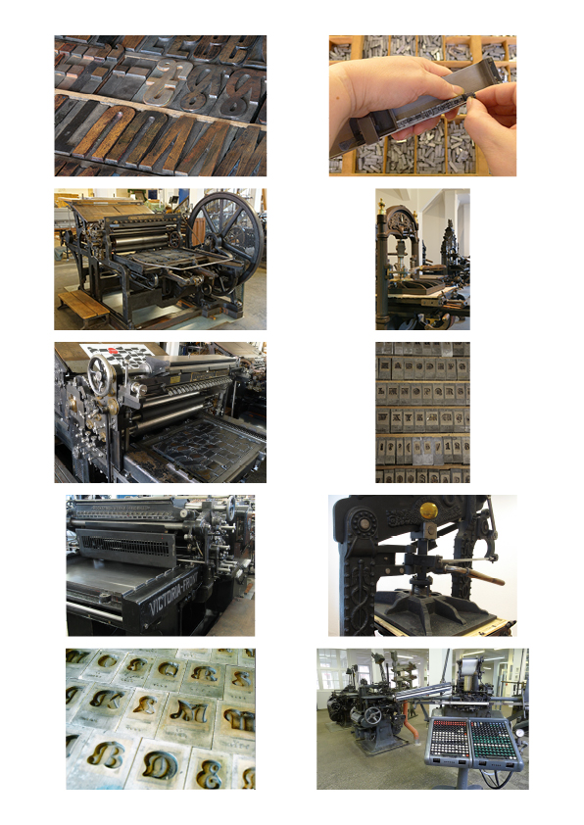

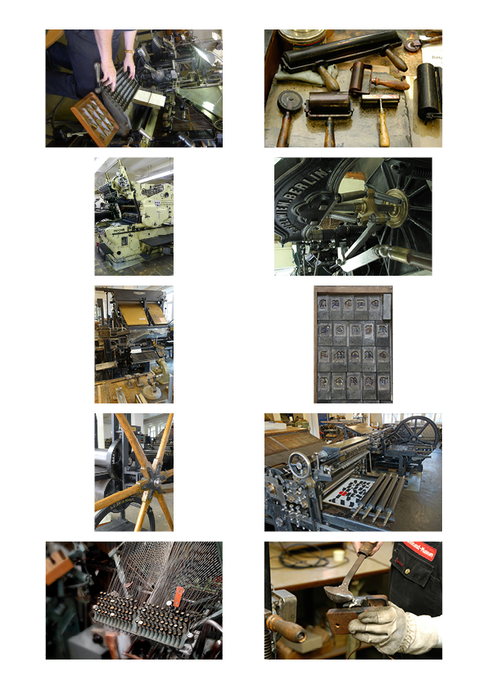

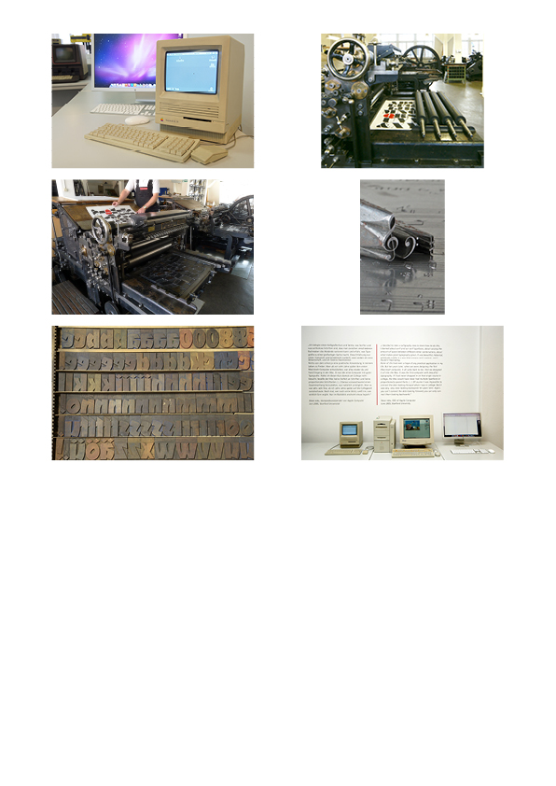



QR-Code: minimum size: 20 x 20 mm
File: druckkunst.png
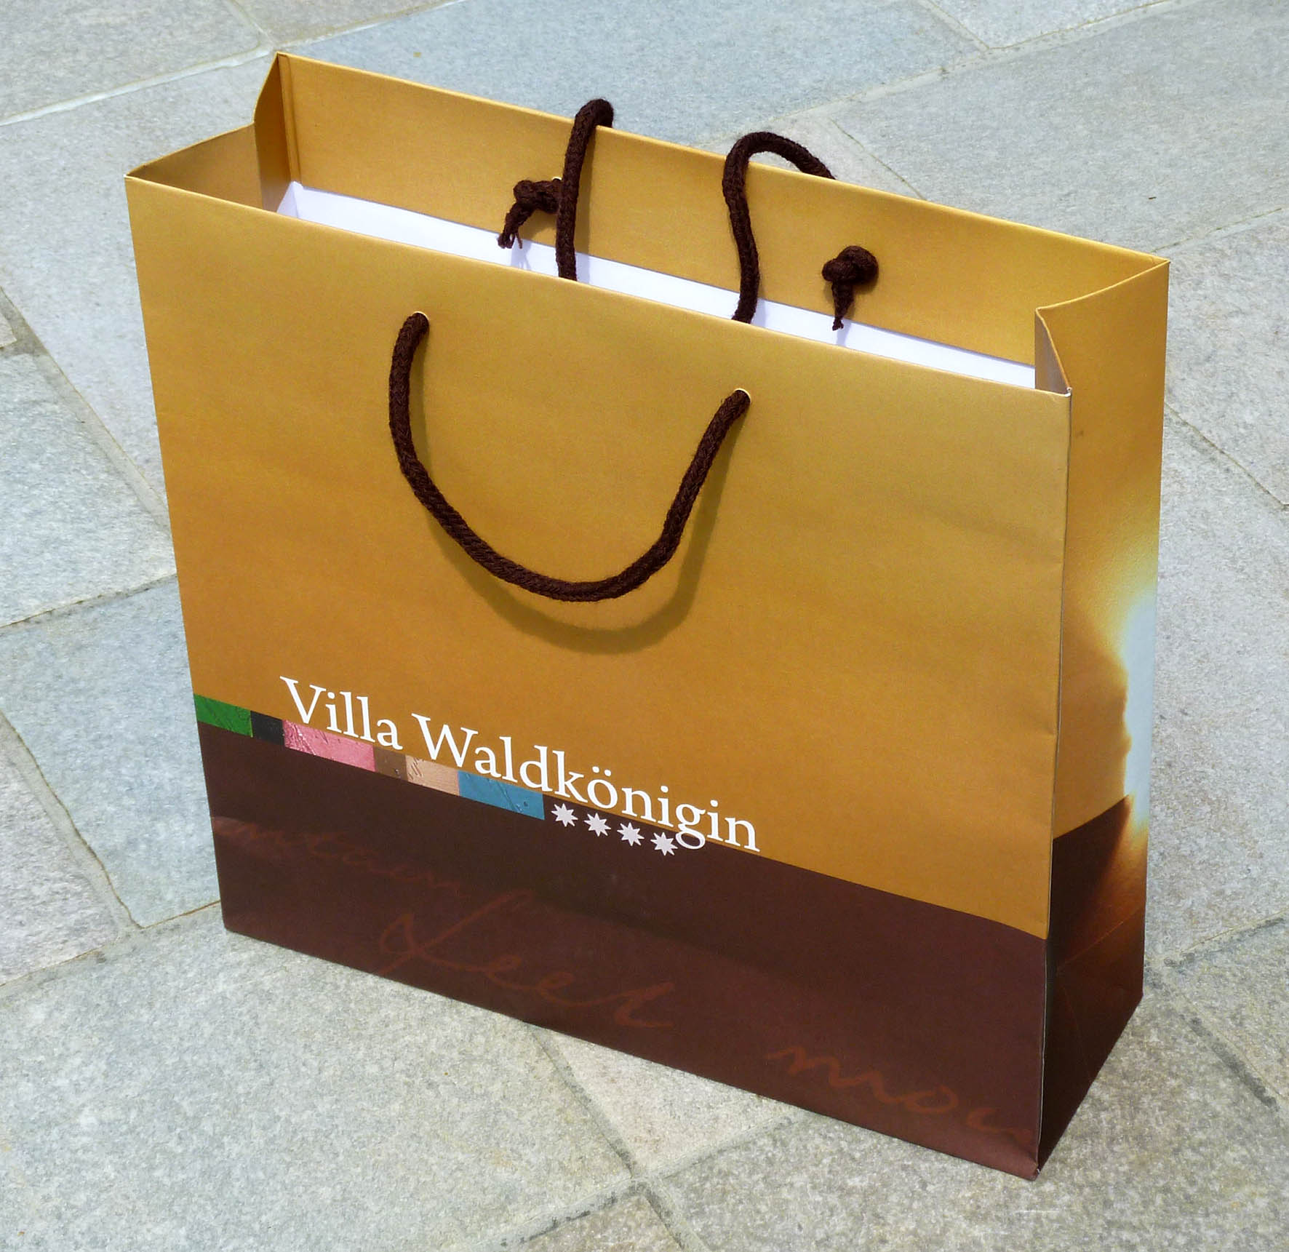
QR-Code：最小大小為20 x 20 mm
檔案：druckkunst.png

Example of a shopping bag with the given DieCut
購物袋範例和購物袋刀模
given DieCut
提供的刀模

